Personas

# What is a Persona?

*“Personas are archetypes that describes the various goals and observed behavior patterns among your potential users and customers”.* A persona can be thought of as a hypothesized character who demonstrates the most critical behavioral data in a way that designers and stakeholders can understand, remember and relate to.

The goal for creating this hypothesized character/persona is to be able to deeply understand what the user actually wants. According to Alan Cooper – “*Personas are the single most powerful design tool that we use. They are the foundation for all subsequent goal-directed design. Personas allow us to see the scope and nature of the design problem…”*

# How did I create personas for eco-car?

To come up with Personas for ECO-CAR, I devised the following plan and proceeded accordingly:

1. **Conduct interviews and try to create an interactive environment to be able to know and capture the exact user requirements.**

Conducting interviews is indeed the best way to start when one has to create a persona. My motivation was to be able to extract maximum information. My idea was to create an interactive environment which would make the interviewee comfortable and along with answering questions, the interviewee should speak candidly when asked about what would be his dream car.

The interview questions were very detailed and covered personal, professional and aspirations of an interviewee.

1. **Condense the captured data.**

When the captured data was condensed, I got the holistic view of the user requirements.

1. **Refine the data and Create user groups to create persona.**

Data collected after interviews helped to form different user groups. These groups were divided on the *age, occupation and* *car desired criteria* which helped to create the persona.

1. **Make persona Realistic.**

To make the persona realistic, appropriate descriptions of each personas background, motivations, and goals was developed.

# Context of use

1. **Muscle car:**

A muscle car, by the strictest definition, is an intermediate sized, performance oriented model, powered by a large V8 engine, at an affordable price. Most of these models were based on "regular" production vehicles. These vehicles are generally not considered muscle cars, even when equipped with large V8s. If there was a high performance version available, it gets the credit, and not the vehicle that it was based on. The Muscle car has evolved over time to include such modern muscle cars as the Mustang, Camaro, Charger, Challenger, and the GTO. The lone wolf in this list is the Dodge Charger because it is the only four door listed among the others. Some would say yes, and others would say no. To answer that question, one has to look back on the history of the muscle car during its heyday in the late 60s and early 70s. During that time the target horsepower to weight ratio for a car to be classified as a muscle car was 10 lbs per horsepower. The times have changed though, and most of the modern cars that fit into the muscle car category contain many options and come with hefty price tags. Some of these changes were made in response to stricter government regulations on safety and fuel mileage, while others came about as customer's preferences changed. The people who grew up during the pinnacle of the muscle car years are getting older, and want their cars to have all of the modern amenities along with ground-pounding power. As a result, the modern muscle car is far removed from those of long ago, but the general idea is not dead. With the SRT 8 Charger and Challenger, Mustang GT, and SS Camaro all making more than 400hp and running sub 13 sec quarter miles, the muscle car is far from dead. In fact, it can be argued that the best muscle cars are the current ones.

1. **Hybrid Car:**

A hybrid car is one that uses more than one means of propulsion. At the moment, that means combining a normal petrol or diesel engine with an electric motor. The chief advantages of a hybrid are that it uses less fuel and emits less CO2 than most conventional non-hybrid vehicles. Because of this, owners also get extra benefits in the shape of lower rates of road and company car tax, as well as possibly avoiding congestion charges. Effectively, they are a halfway house between conventional hybrids and full electric vehicles. Although they have a conventional engine, they also have larger batteries than regular hybrids and can drive longer distances on electric power alone - up to 30 miles in some cases.

1. **ECO-CAR:**

An Eco-Car is a combination of both Muscle and Hybrid. In its development stage, eco-car is already attracting a lot of people. Eco car can also be thought of as ”*prediction of future*” as it will not only provide muscle but will be environment safe. The eco car incorporates most of the latest technologies. In an individual comparison to both muscle and hybrid, Eco Car exceeds the buyers’ expectation by a long margin. A car with muscle to satisfy adrenaline rush of a muscle lover along with minimal impact to the environment. Eco-Car

# Personas i created:-

1.

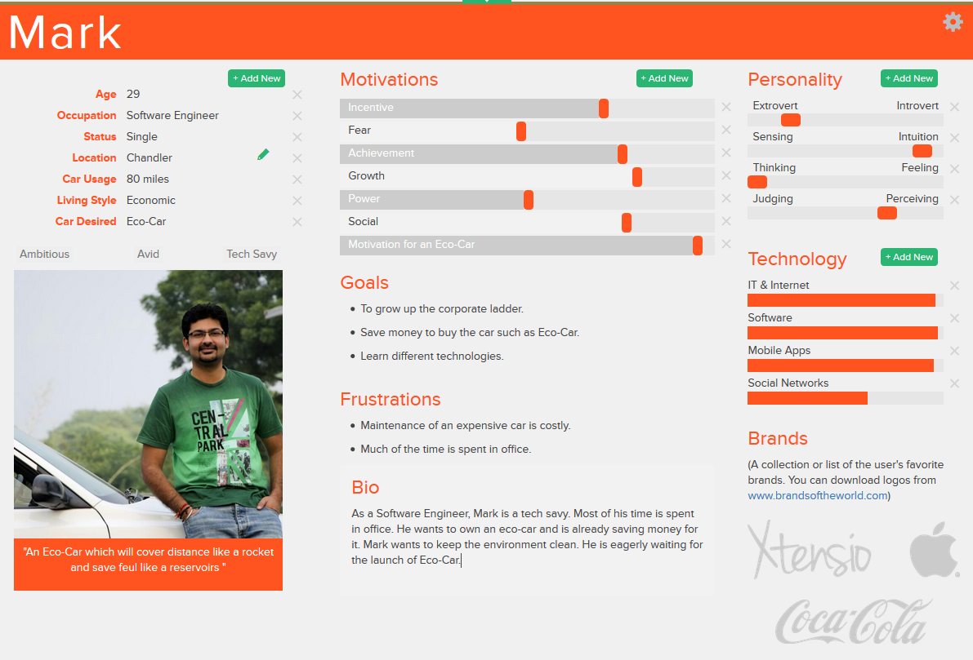

2.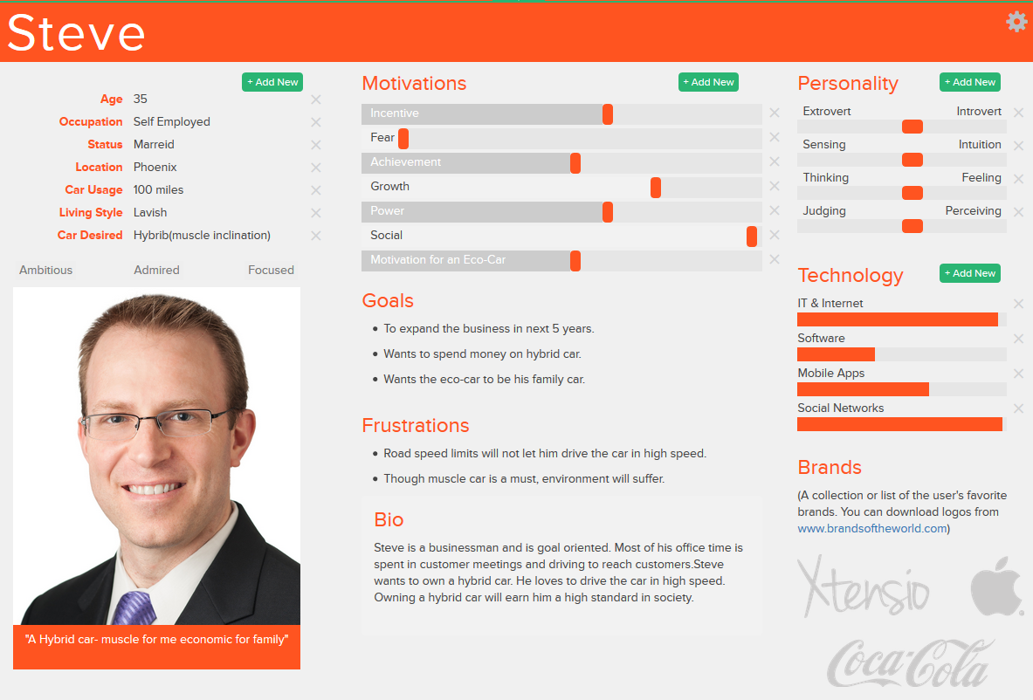3.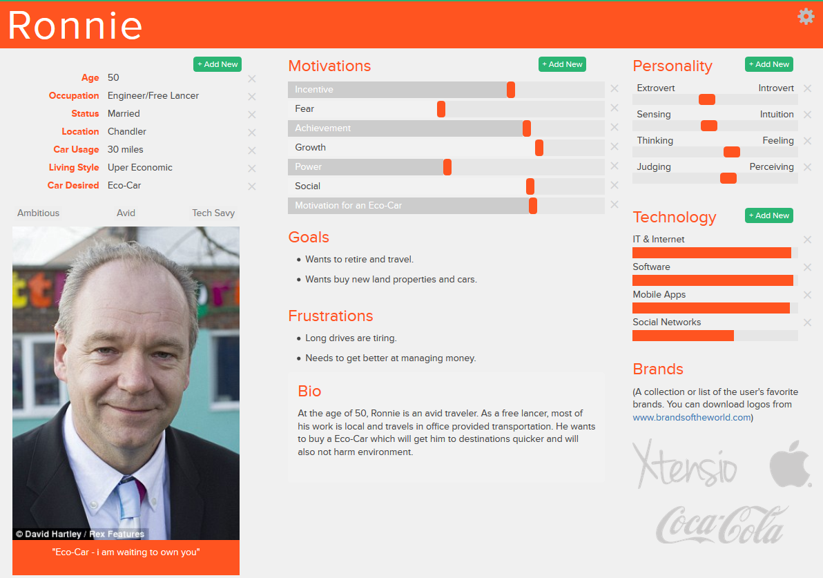

References:

<http://ieeexplore.ieee.org.ezproxy1.lib.asu.edu/stamp/stamp.jsp?tp=&arnumber=1391403>

<http://research.microsoft.com/en-s/um/redmond/groups/coet/grudin/personas/old%20versions/pruitt-grudinrev2.pdf>

<http://www.cooper.com/journal/2001/08/perfecting_your_personas>

<http://www.dubberly.com/articles/alan-cooper-and-the-goal-directed-design-process.html>

<https://app.xtensio.com>